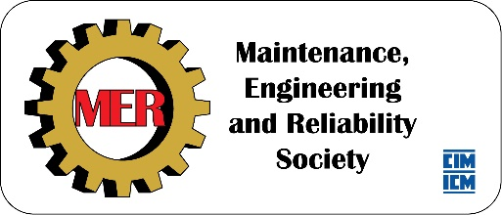

2018 Scholarship application malfunction -
MER Scholarship applicants must re-submit
In connection with our transition to a paperless application process coinciding with the launch of the new Maintenance Engineering & Reliability Society website, there has been a mix-up.
The applications of most students who applied for MER Scholarships before the October 31st deadline did not make it to the target inbox. We are unable to retrieve them, and we do not have a record of those who sent a submission.
We wholeheartedly apologize to those who have applied, but have no choice but to ask you to submit your materials again.
For those who applied before the October 31st deadline, please forward us a copy of your original email submission with attachments. Your application will be prioritized.
If you did not apply before the October 31st deadline but would like to be considered for a MER scholarship, we are willing to receive your application. Please download and complete an application form and send your application to MER.Scholarships@cim.org before midnight on January 31st, 2019.
We thank you for your understanding, best of luck to the applicants and Happy Holidays to all.

Sincerely,
Dean Millar, Scholarships Coordinator, MER Executive Team

